**Introduction**

With the most recent version of R, a significant number of students are having issues using R on their Mac laptops. There have been problems arising due to the downloading or updating of R packages that are necessary for learning R. The university has provided an alternative for working in R through the university-owned servers. The steps below show how to use R remotely on your Mac. More information on the Open OnDemand Service can be found at <https://its.unc.edu/research-computing/ondemand/>

**Step 1 – Registering for Access**

To use the service, you are required to have a Longleaf account prior to logging into Research Computing’s Open OnDemand service. See the following link for more details:

<https://its.unc.edu/research-computing/request-a-cluster-account/>

Faculty, staff, undergrad and graduate students can request an account by following these steps:

1. Go to [help.unc.edu](https://help.unc.edu/) and log in with your onyen.
2. Search for *Compute Cluster Access* in the catalog section of [help.unc.edu](https://help.unc.edu/sp?id=search&spa=1&q=Compute%20Cluster%20Access&t=sc).
3. Click on Computer Cluster Access.
4. Complete the service request form and click “Request”.

You will be notified by email when your account is ready.

**Step 2 – Download the VPN Client Cisco AnyConnect**

Go to <https://software.sites.unc.edu/shareware/#c> and find the Mac download for the VPN Client Cisco AnyConnect. Download the appropriate file and install on your computer.

**Step 3 – Log into Cisco AnyConnect**

Now that Cisco AnyConnect is installed on your computer, you need to run it in order to access UNC’s virtual private network. This is required before jumping to the next step. Open Cisco AnyConnect and make sure you are set to connect to vpn.unc.edu. If you are accessing the internet from the Eduroam network provided on campus you do not need to do this.

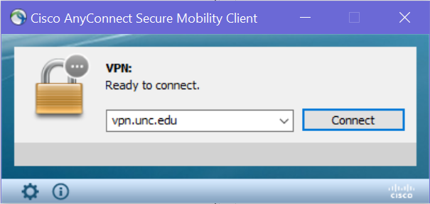

Then, use your Onyen and password to login. You will need to type “push”, “phone”, or “sms” for the 2-step verification process. Personally, I usually type “phone” and press the “#” sign.

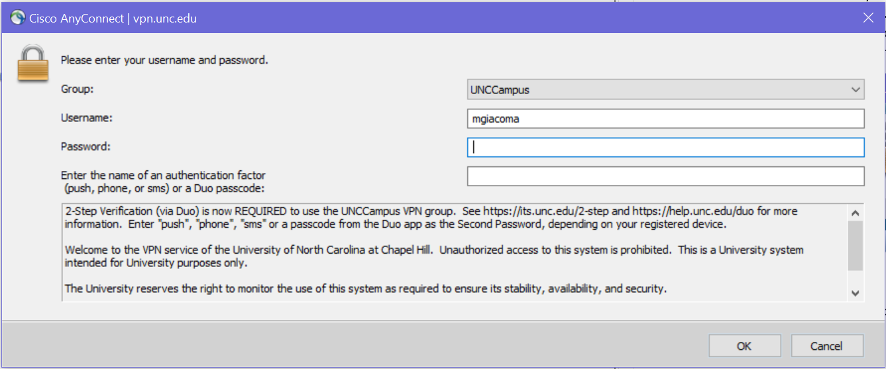

**Step 4 – Access OnDemand**

In your browser, navigate to [https://ondemand.rc.unc.edu](https://ondemand.rc.unc.edu/). You will again need to sign in using your Onyen and password.

**Step 5 – Open RStudio Desktop**

In the top menu, there is a drop down menu for “Interactive Apps”. Select “RStudio Desktop”. Next, you will need to specify a length of time you plan to use RStudio for. This is measured in hours. Then, select “Launch”. You will be put in a queue and have to wait some length of time.

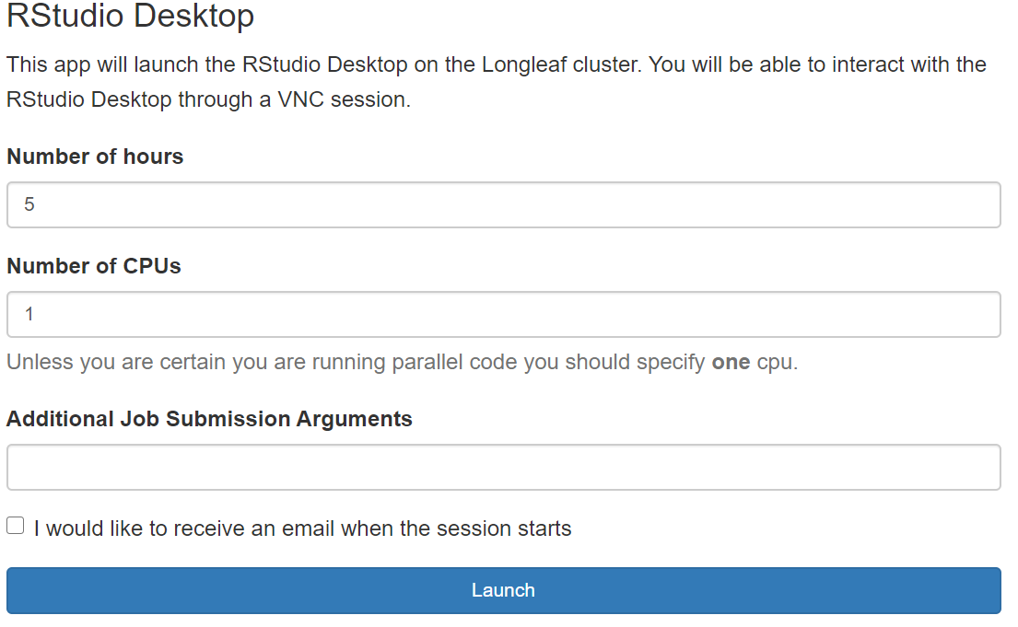

After some time, you will be able to launch RStudio Desktop. This should open up in a new tab in your browser or new window.

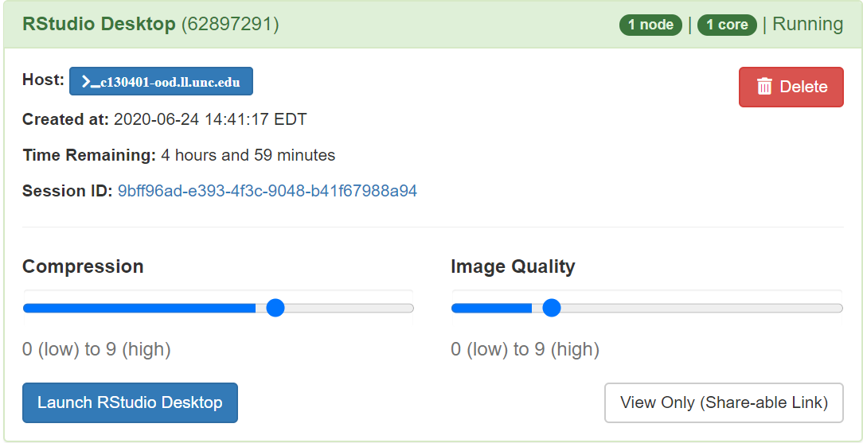

**Step 6 – Test out R**

You are know working on a virtual computer from a Linux server. Select the upward arrow in the RStudio window to maximize. To check that everything works, practice creating a new RMarkdown (Rmd) file.

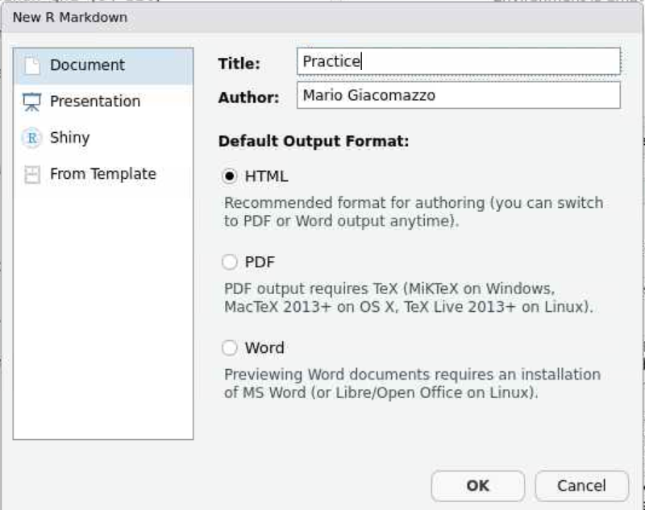

For a test, Knit the Rmd file to HTML. You will then be led to give it a file name and you can see the place in the server where your file will be saved to.

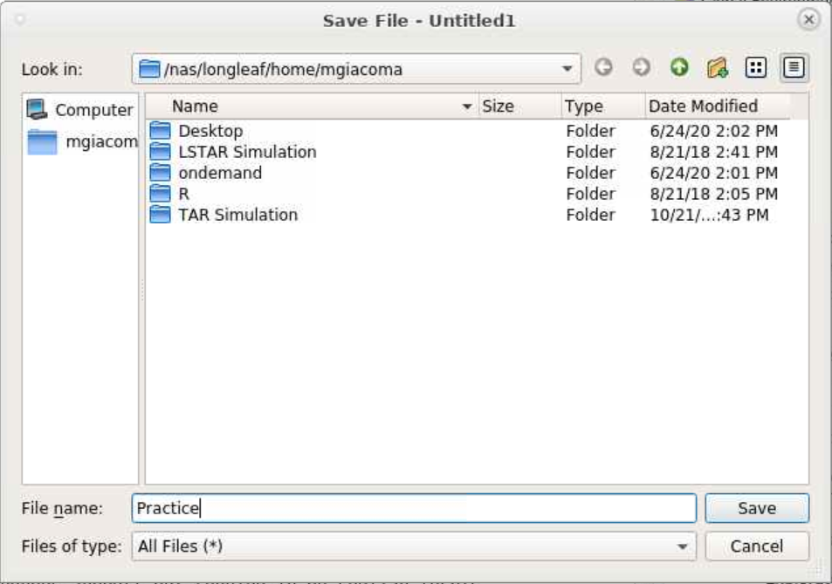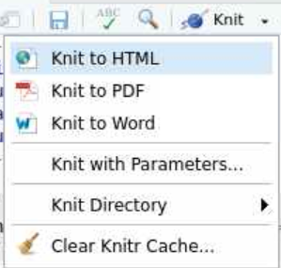

As a student at UNC, you have enough space on the server to handle all of your files. When you save your Rmd file and Knit the file to HTML, both files will exist in your personal folder on the UNC server. This will be true if you create R Scripts, Notebooks, and Projects.

**Step 7 – Upload and Work from an R file**

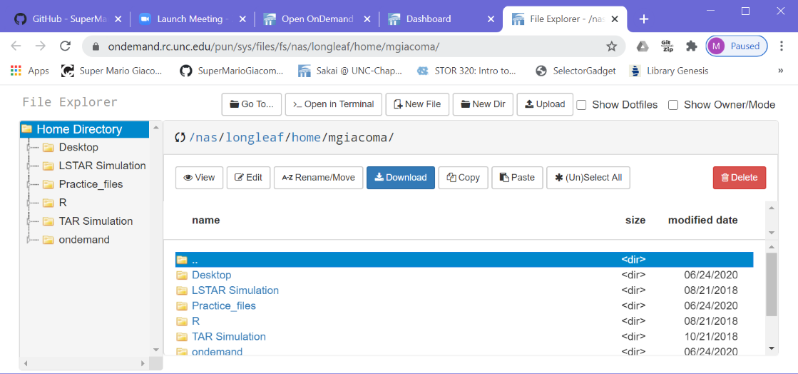 In your class, you may have R files on your computer that you may need to open in R. Here we look at how to upload and run an R file from your computer. If you go back to the OnDemand dashboard where you opened RStudio Desktop, you will see another tab in the top menu called “Files.” Select “Home Directory” in the drop down menu.

Use the “Upload” button to find a file in your computer. I will select this “Lab 1.Rmd” file on my computer for example.

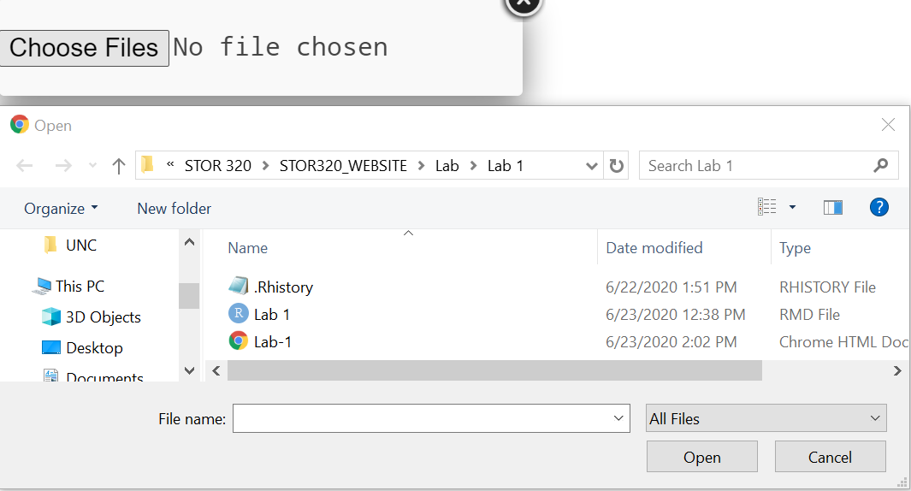

Now, from RStudio Desktop select “Open File”.

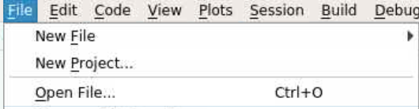

Locate your file on the server and select it.

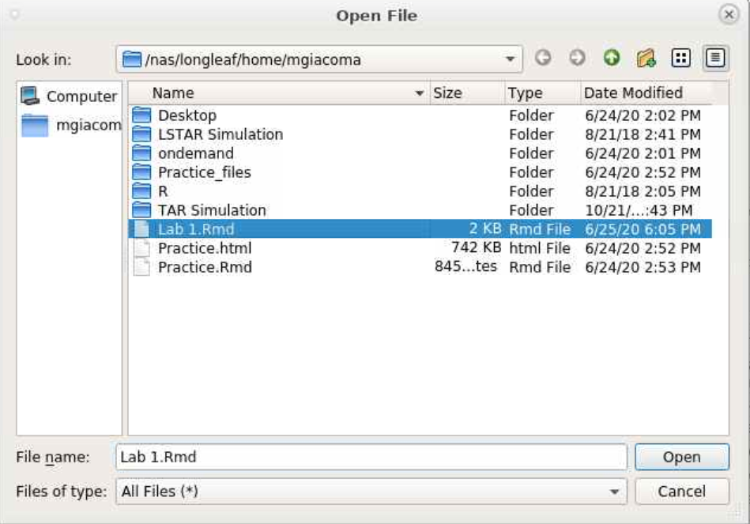

Whenever you save this file, it will update in the folder where it is saved on the server. If you create any graphics, they also will be saved to this computer. For example, if you knit the “Lab 1.Rmd” file to html, you will create “Lab 1.html” in your folder.

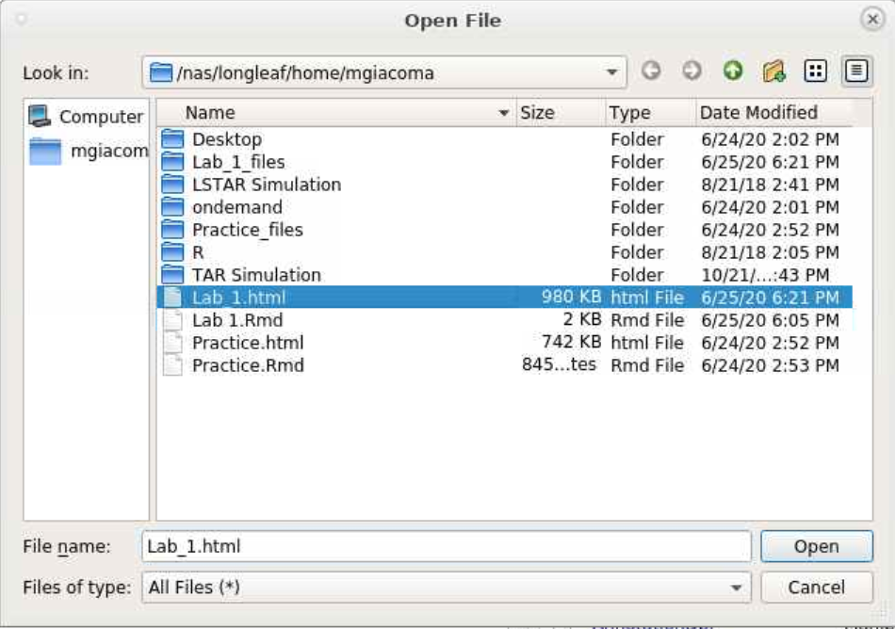

**Step 8 – Download a File from the Server**

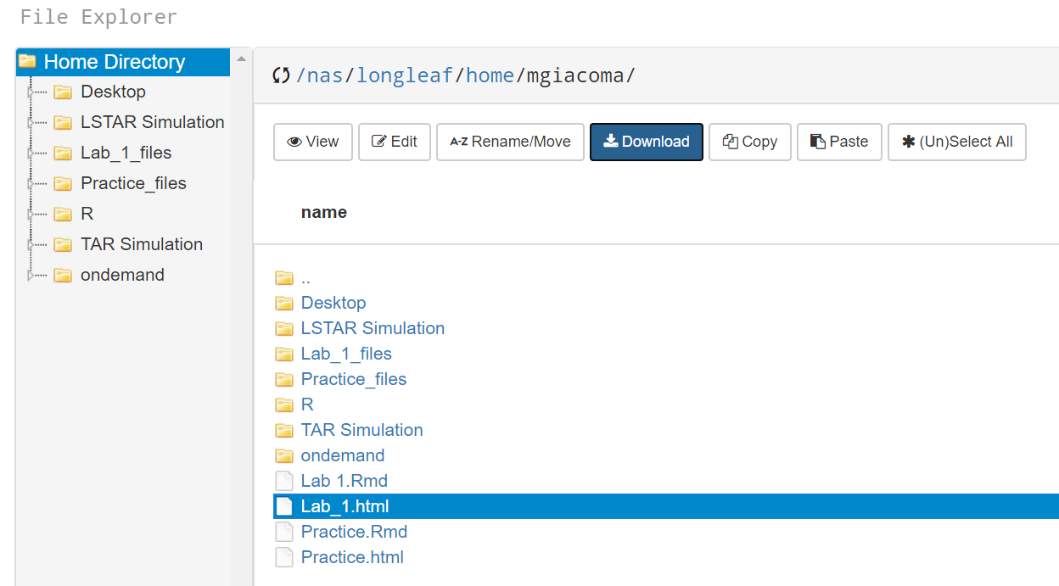When you create a new file in RStudio Desktop, you may need to get that file on your computer so you can submit it for a class. In this last step, we look to download a file from your personal folder on the server. To start, go back to the file explorer tool where we uploaded a file earlier. Here you will see a download button. Select your file and press this button to download the file. By selecting download, your file will immediately start downloading to your computer